**4-Nov-2024**

**Training Day - 72 Report:**

**Introduction of Docker**

Docker is an open-source platform designed to automate the deployment, scaling, and management of applications using containerization technology. It provides a standardized unit of software, known as a container, that packages an application and all its dependencies, enabling it to run consistently across various computing environments.

**Key Concepts of Docker**

**1. Containerization**

**Definition:** Containerization is the process of encapsulating an application and its dependencies into a container. This allows applications to run in isolated environments without interfering with each other.

**Isolation:** Each container operates independently, sharing the host OS kernel but maintaining its own file system, libraries, and configuration files. This isolation helps prevent conflicts between applications.

**2. Docker Images**

**Definition:** A Docker image is a lightweight, standalone, executable package that includes everything needed to run a piece of software, including the application code, libraries, dependencies, and runtime.

**Layered Architecture:** Docker images are built in layers, where each layer represents a set of file changes. This layered structure allows for efficient storage and sharing of common layers across different images.

**Dockerfile:** Images are created from a Dockerfile, a text document that contains a series of commands and instructions to assemble the image. The Dockerfile specifies the base image, application code, dependencies, and configuration.

**3. Docker Containers**

**Definition:** A Docker container is a running instance of a Docker image. It is a lightweight, standalone environment where the application runs.

**Lifecycle:** Containers can be created, started, stopped, and removed. They are ephemeral by nature, meaning they can be easily destroyed and recreated.

**Resource Efficiency**: Containers share the host OS kernel, making them more efficient in terms of resource usage compared to traditional virtual machines (VMs).

**4. Docker Engine**

**Definition:** The Docker Engine is the core component of Docker that enables users to create, run, and manage containers. It consists of a server (the Docker daemon), a REST API, and a command-line interface (CLI).

**Architecture:** The Docker daemon manages the containers and images on the host system, while the Docker CLI allows users to interact with the Docker daemon through commands.

**5. Docker Hub**

**Definition:** Docker Hub is a cloud-based registry service for sharing and managing Docker images. It allows users to store and distribute images publicly or privately.

**Pre-built Images:** Docker Hub hosts a wide range of pre-built images, making it easy for developers to find and use existing software packages.

**Advantages of Using Docker**

1. **Consistency Across Environments:** Docker ensures that applications run the same way in development, testing, and production environments, reducing "it works on my machine" issues.
2. **Isolation:** Each container runs in its own environment, preventing conflicts between applications and making it easier to manage dependencies.
3. **Portability:** Docker containers can run on any system that supports Docker, allowing for seamless movement of applications across different environments.
4. **Scalability:** Docker makes it easy to scale applications by adding or removing containers based on demand. This is particularly useful in microservices architectures.
5. **Resource Efficiency**: Containers are lightweight and can start quickly, leading to better resource utilization compared to traditional virtual machines.
6. **Rapid Deployment:** Docker allows for faster application deployment by enabling developers to package applications and their dependencies together.
7. **Microservices Support:** Docker is well-suited for microservices architectures, where applications are broken down into smaller, independent services that can be developed, deployed, and scaled independently.
8. **Version Control:** Docker images can be versioned, allowing developers to track changes, roll back to previous versions, and maintain multiple versions of an application.
9. **Integration with CI/CD:** Docker integrates well with Continuous Integration and Continuous Deployment (CI/CD) pipelines, enabling automated testing and deployment of applications.
10. **Community and Ecosystem:** Docker has a large community and a rich ecosystem of tools, libraries, and extensions that enhance development workflows.

**Use Cases for Docker**

1. **Development Environments:** Developers can create consistent environments for their applications, reducing setup time and conflicts.
2. **Microservices:** Docker facilitates the development and deployment of microservices by allowing each service to run in its own container.
3. **Continuous Integration/Continuous Deployment:** Docker enables automated testing and deployment processes in CI/CD pipelines.
4. **Cloud Deployments:** Docker containers can be easily deployed on cloud platforms, making it an ideal choice for cloud-native applications.
5. **Legacy Application Migration:** Docker can be used to containerize legacy applications, making them easier to deploy and manage in modern environments.

**Conclusion**

Docker is a powerful tool that has transformed how applications are developed, deployed, and managed. Its containerization technology provides a consistent, efficient, and scalable

**5-Nov-2024**

**Training Day - 73 Report:**

**Containers and Docker**

1. **Through Docker Container deploy a project:**  
   Docker containers are lightweight, standalone packages of software that include everything needed to run an application (code, libraries, dependencies, etc.). This makes deploying projects fast and consistent across different environments.
2. **Make folders and put Vagrant file:**
   * Vagrant is a tool for managing virtual machine environments.
   * A Vagrantfile is a configuration file that defines the setup for the virtual environment, such as specifying the base operating system, networking, and provisioning tools like Docker.
3. **Search docker.com:**
   * Visit Docker’s official website (https://www.docker.com/) to download and install Docker, and explore its features, documentation, and tutorials.
4. **Install Docker:**
   * Docker installation steps include setting up Docker’s repository, adding its GPG key, and installing Docker packages (as shown in your earlier script).
5. **Vagrant up:**
   * The vagrant up command initializes and starts the virtual environment defined in the Vagrantfile. If Docker provisioning is included, Docker will be installed and configured within this virtual environment.

**Docker Build Cloud:**

* Docker Build Cloud is likely referring to tools like **Docker Build** or **Docker Hub**:
  + **Docker Build**: Command to build Docker images locally or in CI (Continuous Integration) environments.
  + **Docker Hub**: A cloud-based registry service that allows you to host and share container images.
* These tools make it easier to create, store, and deploy Docker images.

**Commands Explanation:**

1. **vagrant ssh:**
   * Connects to the Vagrant-managed virtual machine using SSH. Once connected, you can run commands inside the VM.
2. **systemctl status docker:**
   * Checks the current status of the Docker service (active, inactive, or failed).



1. **sudo -i:**
   * Switches to the root user for elevated privileges, necessary to execute certain Docker commands.
2. **docker images:**
   * Lists all Docker images currently stored on the system, including the image name, tag, and size.



1. **docker ps:**
   * Displays all currently running Docker containers.



1. **docker ps -a:**
   * Shows a list of all containers (both running and stopped).



1. **docker run hello-world:**
   * Runs the hello-world container, which verifies that Docker is installed and functioning correctly.

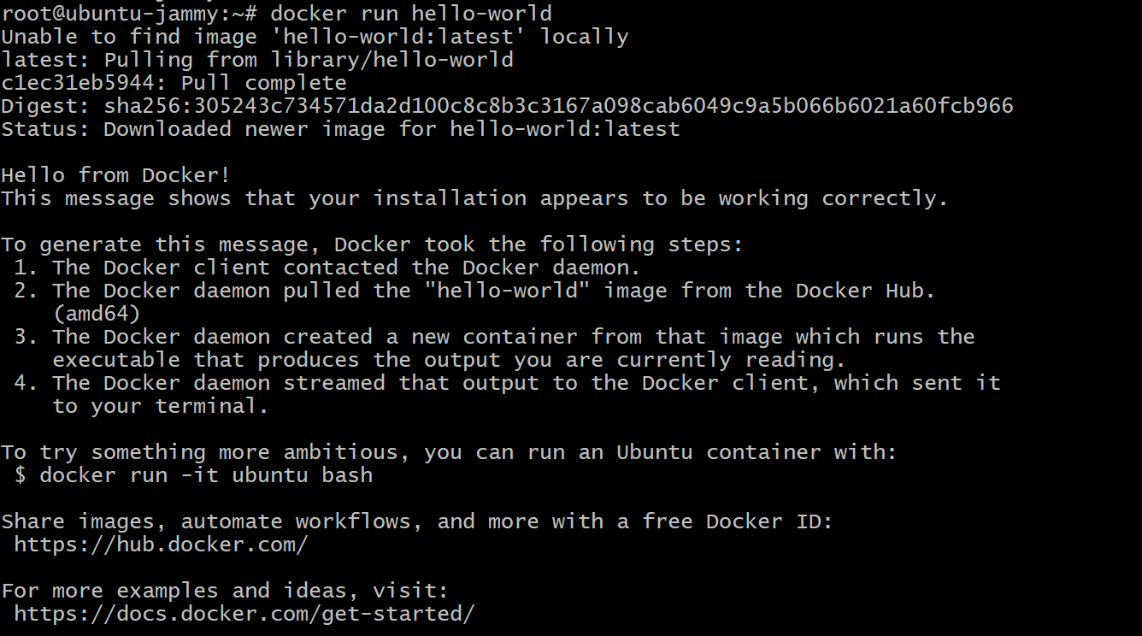

Alternatively:

* + **docker pull hello-world**: Downloads the hello-world image without running it.



**6-Nov-2024**

**Training Day - 74 Report:**

### Commands and Explanations

1. **docker run --name web01 -p 9080:80 nginx:**
   * **docker run**: Starts a new container.
   * **--name web01**: Assigns the name web01 to the container for easy reference.
   * **-p 9080:80**: Maps port 9080 on the host machine to port 80 inside the container. This allows accessing the Nginx server running in the container via http://localhost:9080.
   * **nginx**: Specifies the Nginx image to run.

**Additional Note**:

* + If the -d flag is used, the container will run in the background.

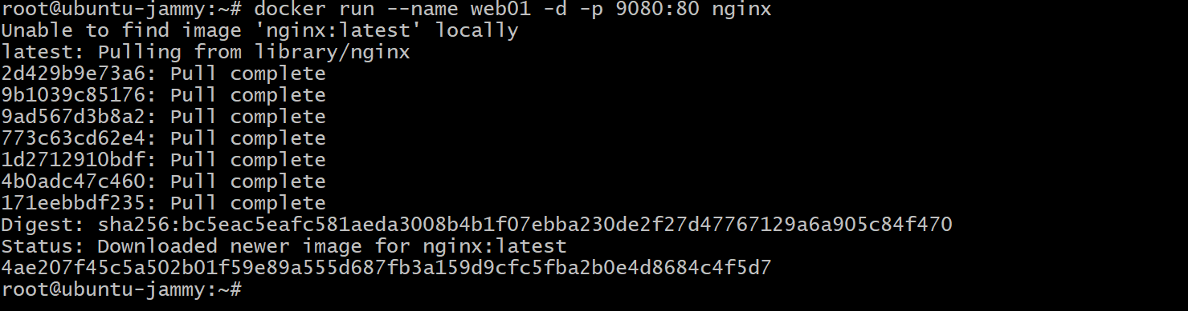

1. **docker inspect web01:**

* Provides detailed information about the web01 container, such as its configuration, network settings, and status.

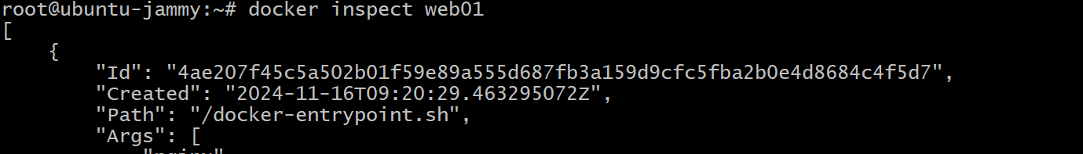

1. **curl http://172.17.0.2:**
   * Sends an HTTP request to the container’s IP address (172.17.0.2 is a typical IP for Docker containers using the default bridge network). This checks if the Nginx server is running and serving content.

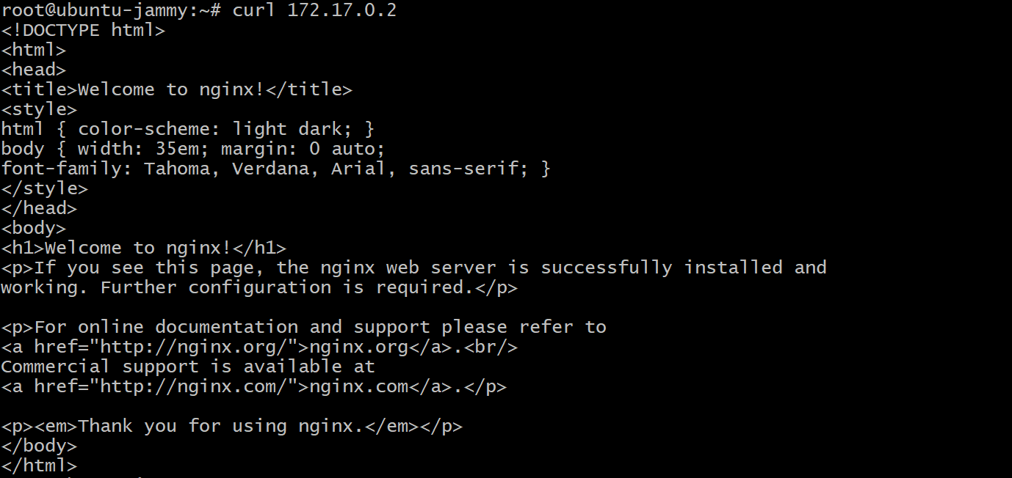

1. **ip addr show:**
   * Displays network interfaces and their associated IP addresses on the host machine. Useful for verifying network configurations.



1. **mkdir images:**
   * Creates a new directory named images. Typically used for organizing Docker-related files (like Dockerfiles or scripts).
2. **cd images:**
   * Changes the working directory to images.
3. **vim Dockerfile:**
   * Opens or creates a Dockerfile using the vim text editor.
   * The Dockerfile contains instructions to build a custom Docker image.

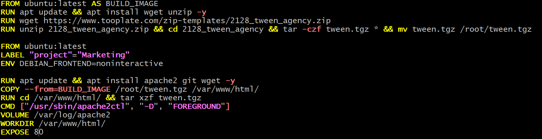

1. **docker build -t testing .:**
   * **docker build**: Builds a Docker image from the current directory (denoted by .) containing the Dockerfile.
   * **-t testing**: Tags the built image with the name testing.

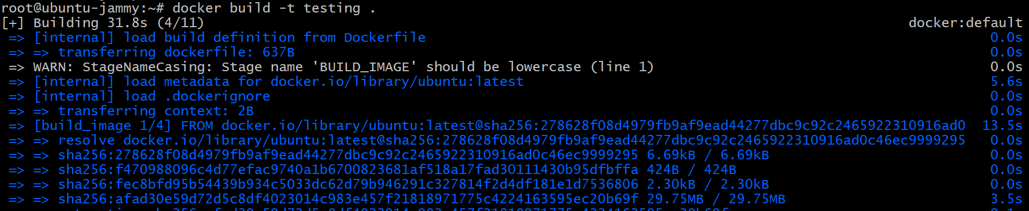

1. **docker run -p 80:80 testing:**
   * Runs a container from the testing image and maps port 80 on the host to port 80 in the container. This exposes the application in the container to the host machine on port 80.  
       
     
2. **docker stop web01:**
   * Stops the web01 container gracefully.



1. **docker rm web01:**
   * Removes the stopped container named web01. Containers must be stopped before they can be removed.



1. **docker images:**
   * Lists all locally available Docker images. Displays repository name, tag, image ID, creation date, and size.



1. **docker rmi <image_id>:**
   * Removes a Docker image by its ID. This helps free up space by deleting unused images.

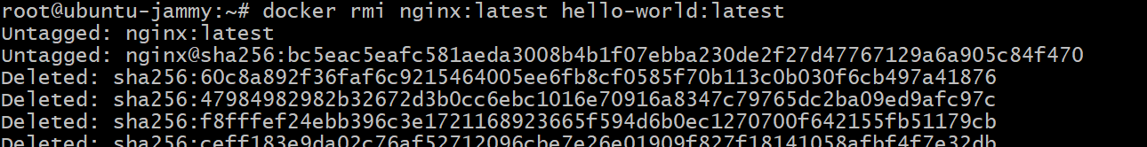

**Summary of Workflow:**

1. Start by running a container (docker run) and mapping ports for accessibility.
2. Use docker inspect and curl to verify that the container is running and accessible.
3. Use mkdir, cd, and vim to create a directory and write a Dockerfile for custom image building.
4. Build a custom image with docker build, run it with docker run, and expose the application via port mapping.
5. Stop and remove containers/images (docker stop, docker rm, docker rmi) as needed to manage resources.

**7-Aug-2024**

**Training Day - 75 Report:**

**Monolithic Architecture in Docker:**

* The entire application is packaged into a single container, which contains all components like UI, business logic, and database access.
* Scaling means replicating the entire container.
* Simpler to set up in Docker but harder to manage and update as the application grows.

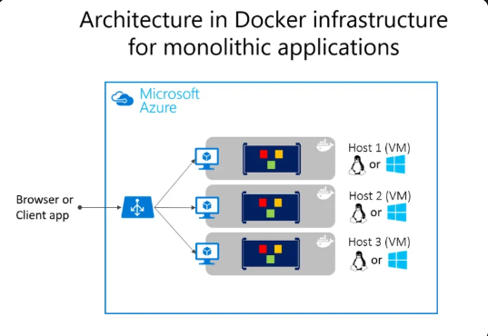

**Microservices Architecture in Docker:**

* Each service (e.g., user service, payment service, inventory service) is deployed in its own container.
* Services communicate with each other using APIs (e.g., REST or gRPC).
* Allows independent scaling, deployment, and updates of each service.

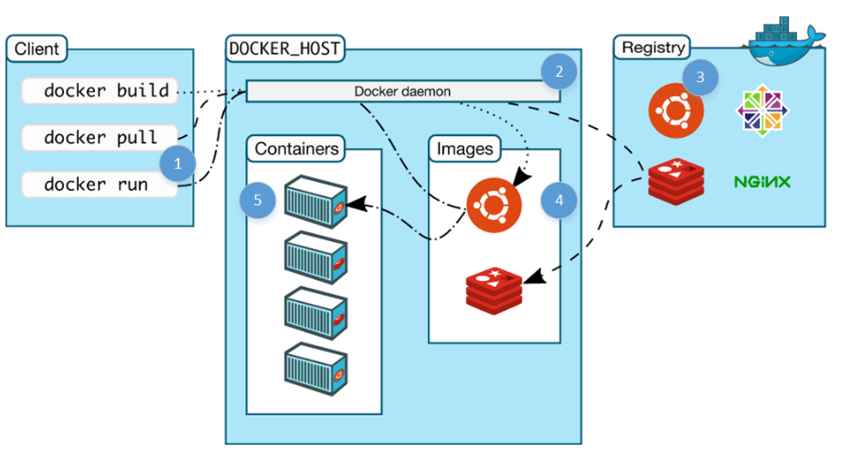

**Comparison:**

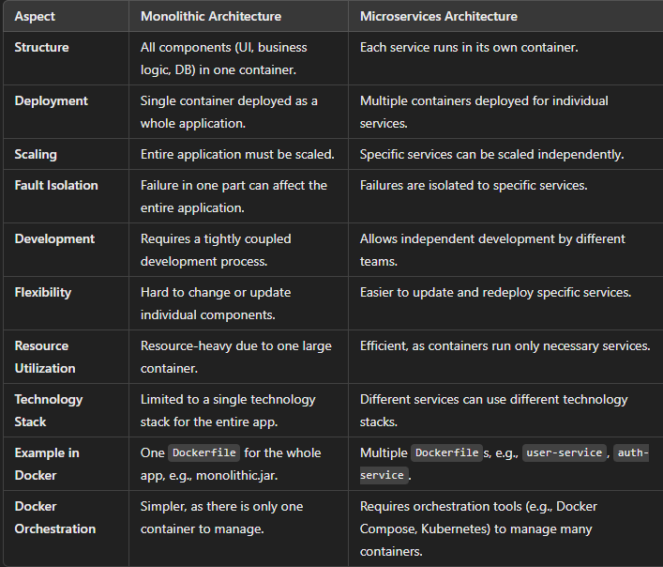

### ****Why Microservices Are More Popular Now:****

1. **Scalability:**
   * Modern applications need to scale specific parts of the system independently. For instance, an e-commerce platform might scale its product catalog service during a sale, without scaling the user authentication service.
   * Microservices, combined with tools like Docker and Kubernetes, make independent scaling efficient.
2. **Flexibility in Technology Stack:**
   * Microservices allow developers to use different languages and technologies for different services. For instance, a company could use Python for machine learning services, Node.js for APIs, and Java for backend processing.
3. **Cloud-Native Applications:**
   * With the rise of cloud platforms (AWS, Azure, GCP), applications are designed to be **cloud-native**. Microservices are better suited to this architecture, leveraging containerization and orchestration tools for deployment.
4. **DevOps and CI/CD:**
   * DevOps practices and Continuous Integration/Continuous Deployment pipelines align well with microservices, enabling rapid updates to specific services without affecting the entire application.
5. **Fault Tolerance:**
   * Microservices provide better fault isolation. If one service fails, it doesn’t bring down the entire system.
6. **Containerization with Docker:**
   * Tools like Docker and Kubernetes have made deploying and managing microservices much easier, allowing businesses to fully embrace the microservices approach.

### ****Where Monolithic Is Still Relevant:****

While microservices dominate modern architectures, **monolithic architecture** is still used in certain scenarios:

1. **Small Applications or Startups**:
   * For simple applications with limited scope and resources, a monolithic approach is faster and easier to develop and deploy.
2. **Legacy Systems:**
   * Many organizations still run legacy systems built on monolithic architecture, as transitioning to microservices can be costly and time-consuming.
3. **Teams with Limited Expertise:**
   * Small teams or those without expertise in managing distributed systems might prefer monoliths for simplicity.

### ****Trends in Industry Usage:****

1. **Microservices + Docker**:
   * Companies like Netflix, Amazon, and Uber rely heavily on microservices and Docker to run their scalable and distributed systems.
2. **Hybrid Approach:**
   * Some organizations adopt a **modular monolith** as a middle ground, where they keep the system unified but use Docker to package different modules for easier management.
3. **Kubernetes and Orchestration:**
   * With Kubernetes becoming the standard for container orchestration, microservices are easier to manage and deploy, further accelerating their adoption.

**8-Aug-2024**

**Training Day - 76 Report:**

**Micro services Using Docker**

**Project: E-Mart Project Deploy Using Docker**

### 1. ****Steps to Deploy****

* **Vagrant up**:
  + Likely the command to initialize and provision a Vagrant virtual machine.
* **Vagrant ssh → sudo -i**:
  + Connect to the Vagrant virtual machine using SSH and switch to the root user with sudo -i.
* **mkdir compose**:
  + Create a directory named compose.



* **cd compose**:
  + Change into the newly created compose directory.



* **touch docker-compose.yml**:
  + Create an empty docker-compose.yml file.



* **vim docker-compose.yml**:
  + Open the  
      
    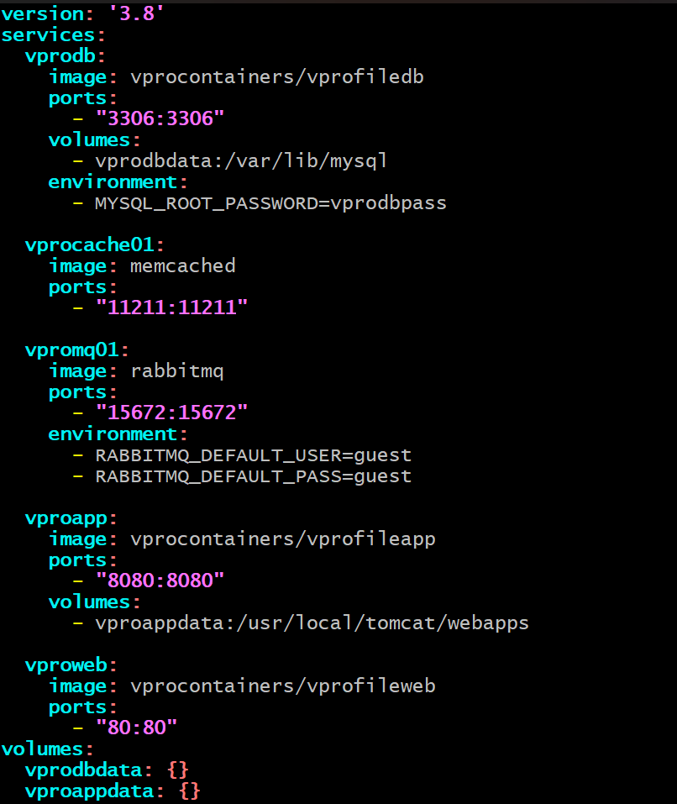

### 2. ****Docker Compose Commands****

* **docker-compose up -d**:
* Start all the services defined in the docker-compose.yml file in detached mode (-d means run in the background).  
    
  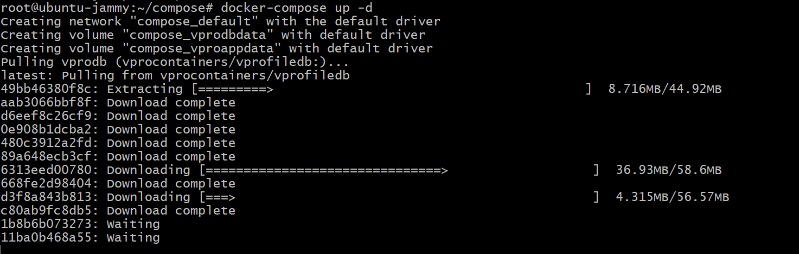
* Note: "not a folder name, keyword" is likely a clarification to avoid confusion about the up command.
* **docker-compose ps**:
  + Show the status of the running containers/services.  
      
    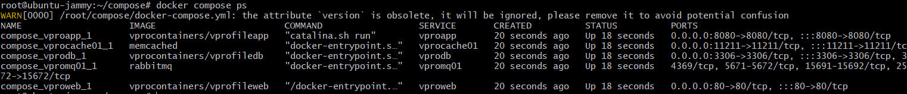
* **ip addr show**:
  + Display the network interface details, which can be used to find the IP address of the machine.
* Project is live:

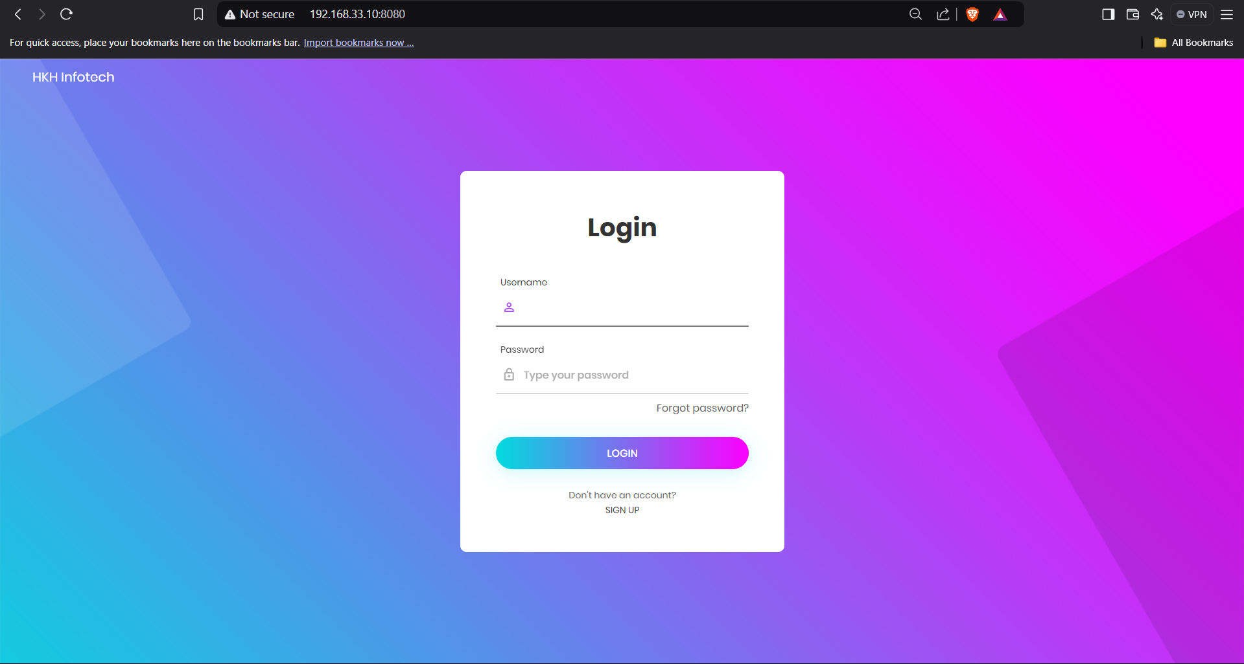

* **docker-compose down**:
  + Stop and remove all the containers, networks, and services started by docker-compose up.

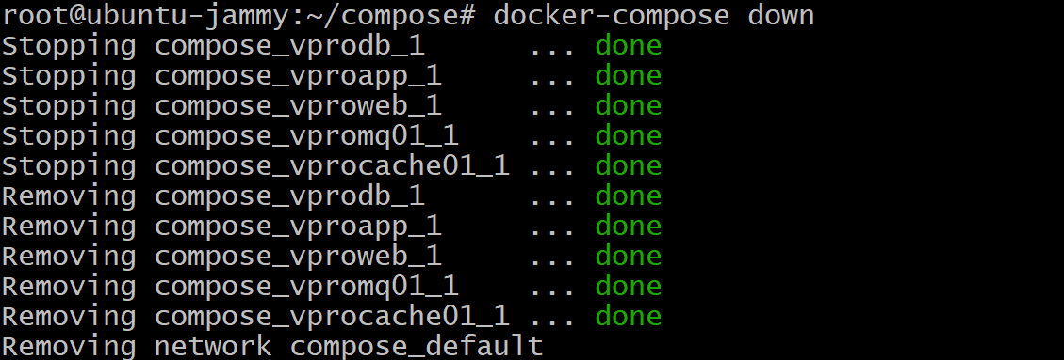

### 3. ****General Notes****

* The notes emphasize basic Docker Compose commands for managing the lifecycle of services.
* A focus on structured steps ensures proper configuration and deployment.